VISVESVARAYA TECHNOLOGICAL UNIVERSITY

BELAGAVI

#### 

*A Mini Project Report on*

“QUIZ MANAGEMENT SYSTEM”

Submitted in the partial fulfillment for the requirements for the conferment of degree of

BACHELOR OF ENGINEERING

In

#### **COMPUTER SCIENCE AND ENGINEERING**

#### By

**Mr. NIKHIL N** USN: 1BY18CS102

**Mr. RAHUL D** USN: 1BY18CS115

Under the guidance of

**Mrs. Ambika G.N**

Assistant Professor

Department of CSE, BMSIT&M.



DEPARTMENT OF COMPUTER SCIENCE AND ENGINEERING

# B.M.S. INSTITUTE OF TECHNOLOGY & MANAGEMENT

**Yelahanka, BENGALURU-560064**

**2020-2021**

**B.M.S INSTITUTE OF TECHNOLOGY & MANAGEMENT**

**Yelahanka, BENGALURU-560064**

**DEPARTMENT OF COMPUTER SCIENCE & ENGINEERING**



**CERTIFICATE**

This is to certify that the Mini Project work entitled **“PROJECT TITLE”** is a bonafide work carried out by **Mr. / Ms. NAME (1BY18CS***)** in partial fulfillment for the award of **Bachelor of Engineering Degree in Computer-Science and Engineering** of the Visvesvaraya Technological University, Belagavi during the year 2020-21. It is certified that all corrections/suggestions indicated for Internal Assessment have been incorporated in this report. The Mini project report has been approved as it satisfies the academic requirements in respect of project work for the B.EDegree.

**______________ __________________**

**Signature of the Guide Signature of the HOD**

Mrs. Ambika G.N Dr. Anil G.N.

**Name of the Examiners Signature with Date**

**1.**

**2**.

**ABSTRACT**

The aim of the project is the have an efficient way to conduct tests and quizzes. This project makes it easier with the provided user interface for the both the teachers and the students. Quiz management system is a system which helps a teacher or a professor or any education body to conduct a quiz with custom question and answers which can be engaged by the student. The record of each student is stored in the database, which makes it easy for the teachers to filter the marks and maintain logs. This also helps in a way of avoiding mal practices as other students cannot access other students attempt.

It becomes difficult to create maintain and handle quizzes in offline mode or through any other 3rd party source. With the increase in technological development its is very hard to cope with the trends. Using this helps take a big jump in a step towards development.

This system has been designed to computerize and automate the operations performed by the faculties to conduct a quiz. Also reduces the workload and improves the management of marks and the curriculum.

**ACKNOWLEDGEMENT**

I am happy to present this Mini project after completing it successfully. This project would not have been possible without the guidance, assistance and suggestions of many individuals. I would like to express my deep sense of gratitude and indebtedness to each and every one who has helped me to make this project a success.

I heartily thank our **Principal, Dr. MOHAN BABU G N,** **BMS Institute of Technology & Management** for his constant encouragement and inspiration in taking up this Mini project.

I heartily thank our **Head of the Department, Dr. Anil G.N, Dept. of Computer Science** **and** **Engineering, BMS Institute of Technology & Management** for his constant encouragement and inspiration in taking up this Mini project.

I gracefully thank Project guide**, Mrs. Ambika G.N, Assistant Professor, Dept. of** **Computer Science and Engineering,** for his/her encouragement and advice throughout the course of the Project work.

Special thanks to all the staff  members of Computer Science Department for their help and kind co-operation.

Lastly I thank my parents and friends for their encouragement and support given to me in order to finish this precious work.

By,

**NIKHIL N**

**RAHUL D**

**CONTENTS**

**Chapters         Page no**

Chapter 1: **Introduction 06**

Chapter 2: **Literature Survey 07**

Chapter 3: **Software Requirements Specification 08**

3.1 Hardware requirements 08

3.2 Software requirements 08

Chapter 4: **Design 09**

4.1 Schema Diagram 09

4.2 Entity-Relationship Diagram                                                    10

Chapter 5: **Implementation 11**

5.1 Implementation with Screen shot 11

Chapter 6: **Conclusion & Future Enhancement 19**

6.1 Conclusion 19

6.2 Future Enhancement 19

Chapter 7: **References 20**

**CHAPTER 1:**

**INTRODUCTION**

Quiz management system is an efficient way to conduct and store records of the quizzes taken up by the students.

The user interface allows the teacher to update/change/add questions to the quiz. The portal lets us login either as a student or teacher. The student can register to the quiz by providing his/her details. The student has to answer to the given set of questions before the timer runs out. The timer starts when the student accepts the instructions given and clicks the begin button.

The teacher can login by giving the required credentials. The teacher can add another question, change the options of a question and delete the question as per the teacher’s requirements. The teacher can view the results of the students who has taken up the quiz. The teacher can sort the list of students based on the marks achieved.

The student portal is interactive. It displays the details of the student, maximum marks and their current score of the test which is updated as they proceed with the test. It also has a running timer which the student can refer to.

This way it makes it easier for both the students and teachers to attend and take up quizzes.

**AIM AND OBJECTIVE**

The project tends to follows certain aims and objectives which have be used to drive the developers into the success of project.

* To help any teacher, professor, faculty or teaching staff and department to easily develop a quiz which can be attempted by the students.
* To build an interface for students which is easy to use and interactive so that the students can easily take up the quiz
* To help teacher maintain the record of students who attempted the quiz and maintain the log.

**CHAPTER 2:**

**LITERATURE SURVEY**

The Quiz Management System (QMS) is a tool that helps examiners conduct quizzes. Generally, the examiner will have to issue questions to the candidates, wait for them to finish their test and the collect the answer scripts back. By using the QMS the candidates can take up the quiz from the homes without any hassle. Evaluating the answer scripts is another time-consuming process. This can be avoided by using the QMS as it automatically increments the score of the candidate for every right answer.

And finally, there wouldn’t be any problem to store and record the details and marks of the candidate as the QMS will automatically record all these details in a tabular form for the examiner.

**CHAPTER 3:**

**Software Requirements Specification**

**Hardware requirements:**

Pentium IV or higher, (PIV-300GHz recommended)

Minimum 256 MB RAM

1 Gb hard free drive space

**Software requirements:**

Java JDK

MS Word 97 or later

Web Browser: Microsoft Internet Explorer, Mozilla, Google Chrome or later

MySQL Server (back-end)

Operating System: Windows XP / Windows7/ Windows Vista

**CHAPTER 4:**

**DESIGN**

SCHEMA DIAGRAM:

QUESTION

|  |  |  |  |  |  |
| --- | --- | --- | --- | --- | --- |
| q_id | q-name | Opt1 | Opt2 | Opt3 | Opt4 |

ANSWERS

|  |  |
| --- | --- |
| q_id | ans |

DETAILS

|  |  |  |  |  |  |  |
| --- | --- | --- | --- | --- | --- | --- |
| usn | name | fname | mname | gender | contact | email |

TENTH

|  |  |  |  |
| --- | --- | --- | --- |
| usn | ten_uni | ten_perc | ten_year |

TWELVE

|  |  |  |  |
| --- | --- | --- | --- |
| usn | twelve_uni | twelve_perc | twelve_year |

GRAD

|  |  |  |  |
| --- | --- | --- | --- |
| usn | grad_uni | grad_perc | grad_year |

MARKS

|  |  |
| --- | --- |
| usn | score |

**Entity-Relationship Diagram**

ten_year

ten_perc

Opt1

q_name

q_id

ten_uni

Opt2

MARKS

score

usn

grad_year

grad_perc

grad_uni

usn

twelve_year

twelve_perc

twelve_uni

GRAD

usn

TWELVE

usn

TENTH

usn

email

contact

gender

m_name

f_name

name

DETAILS

Opt3

Opt4

ans

q_id

ANSWER

Question

1

has

1

1

1

has

1

has

1

1

1

has

N

has

1

**CHAPTER 5:**

**Implementation with Screen shot**

**Creation of Tables:**

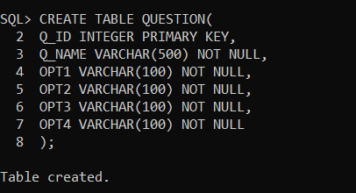

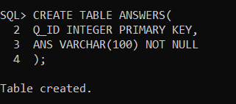

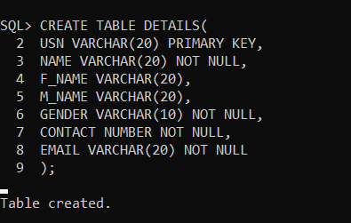

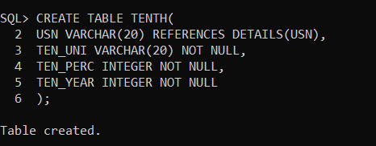

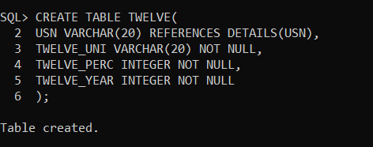

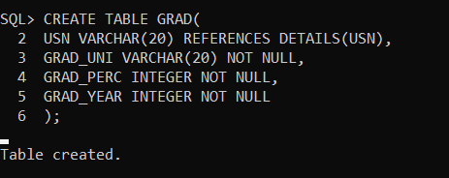

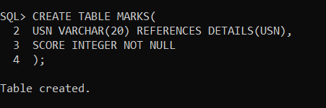

**Execution of Code:**

Index Page

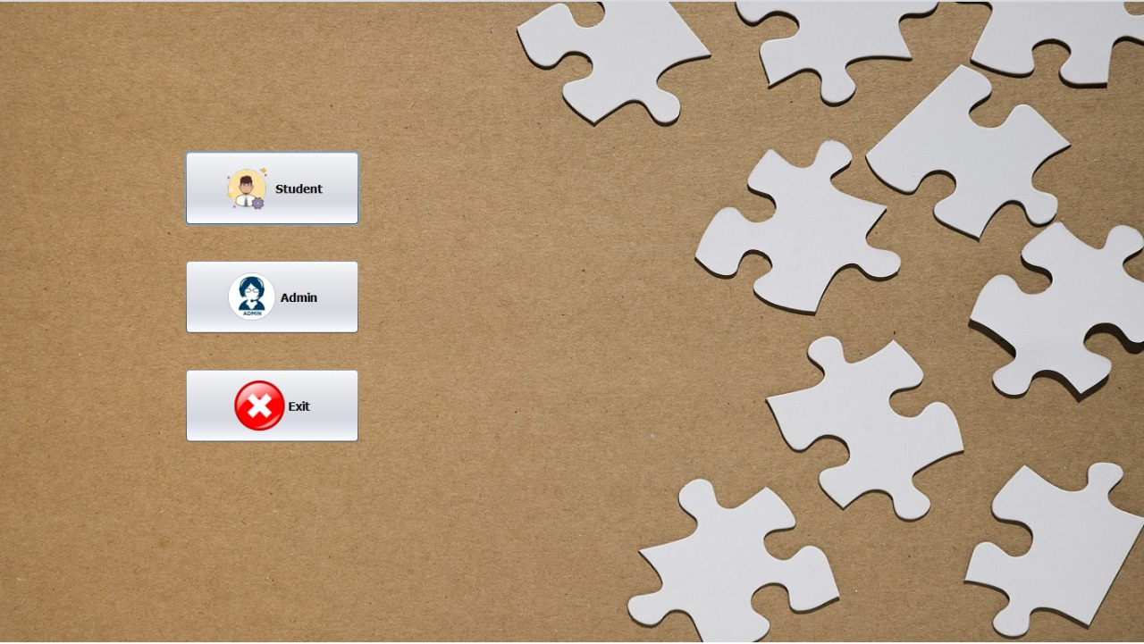

Student Details

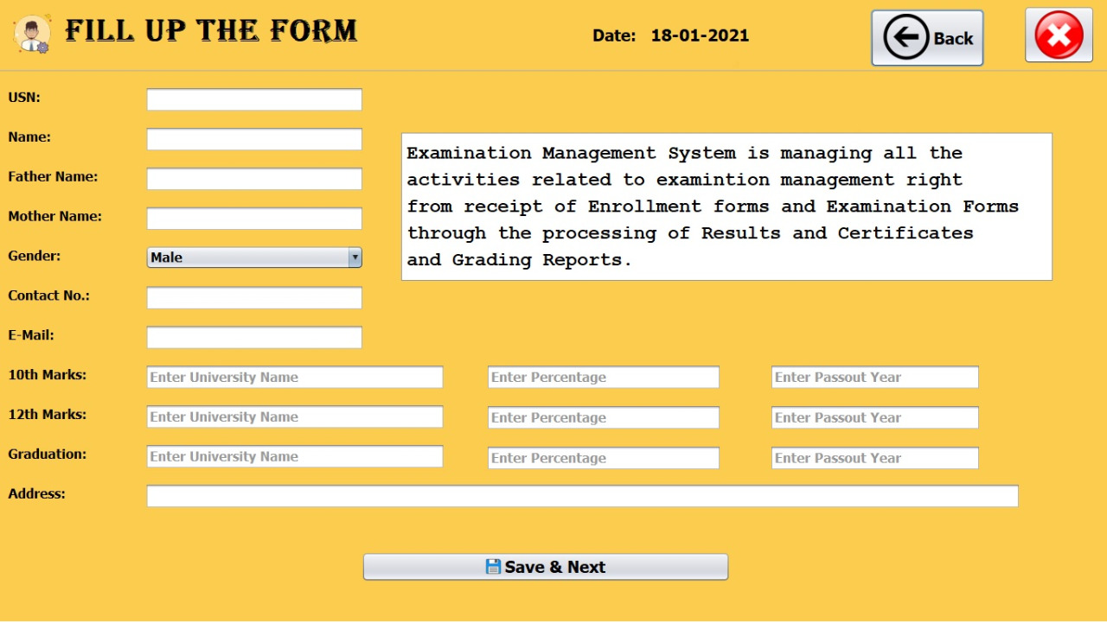

Quiz Instuctions

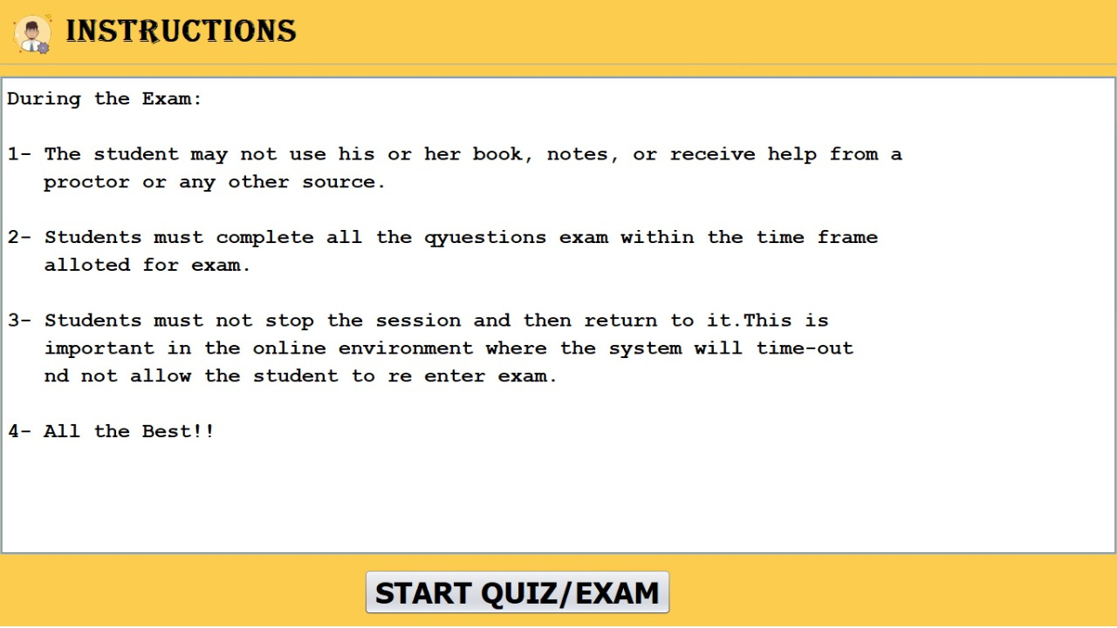

Quiz Attempt Page

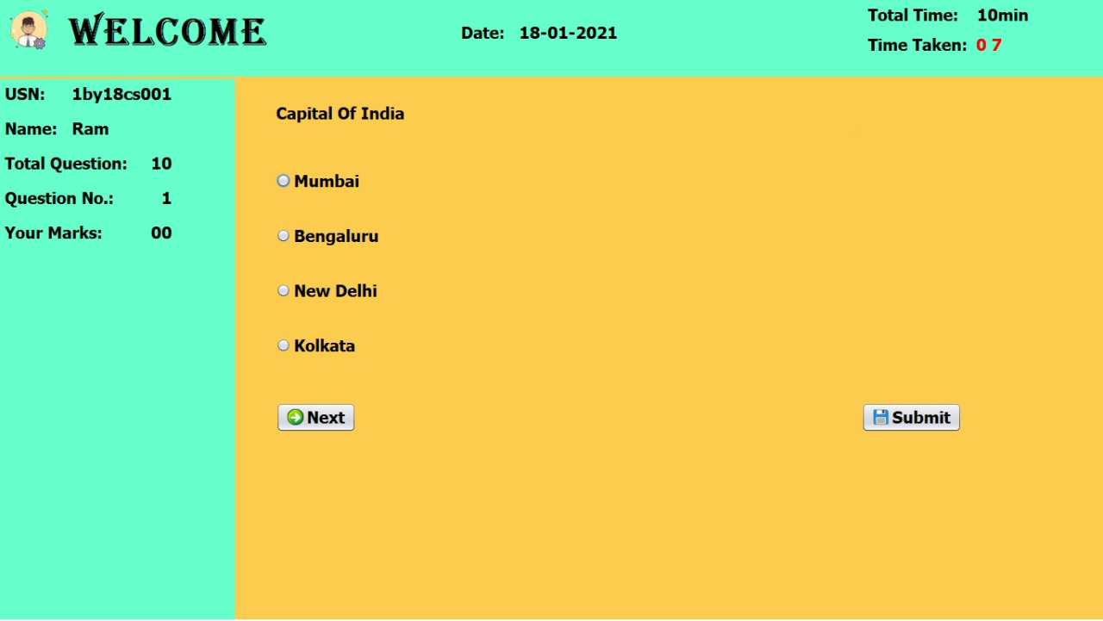

Score Obtained

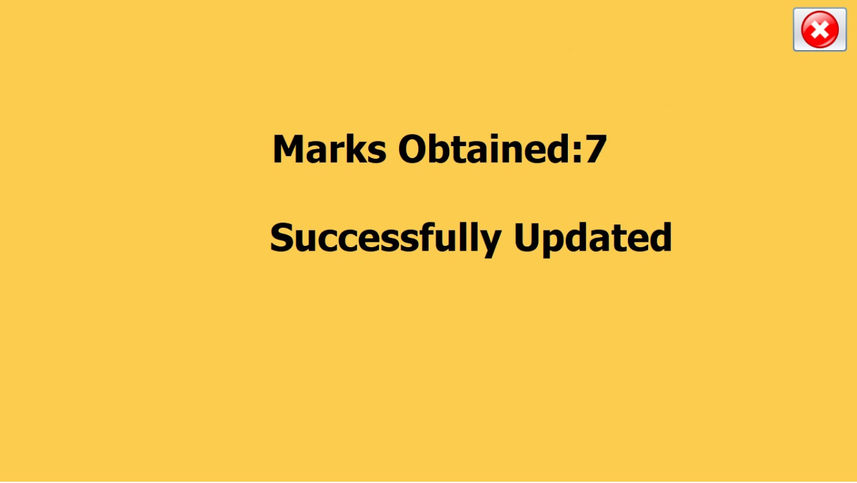

Admin Login Page



Navigation Page



Add New Question

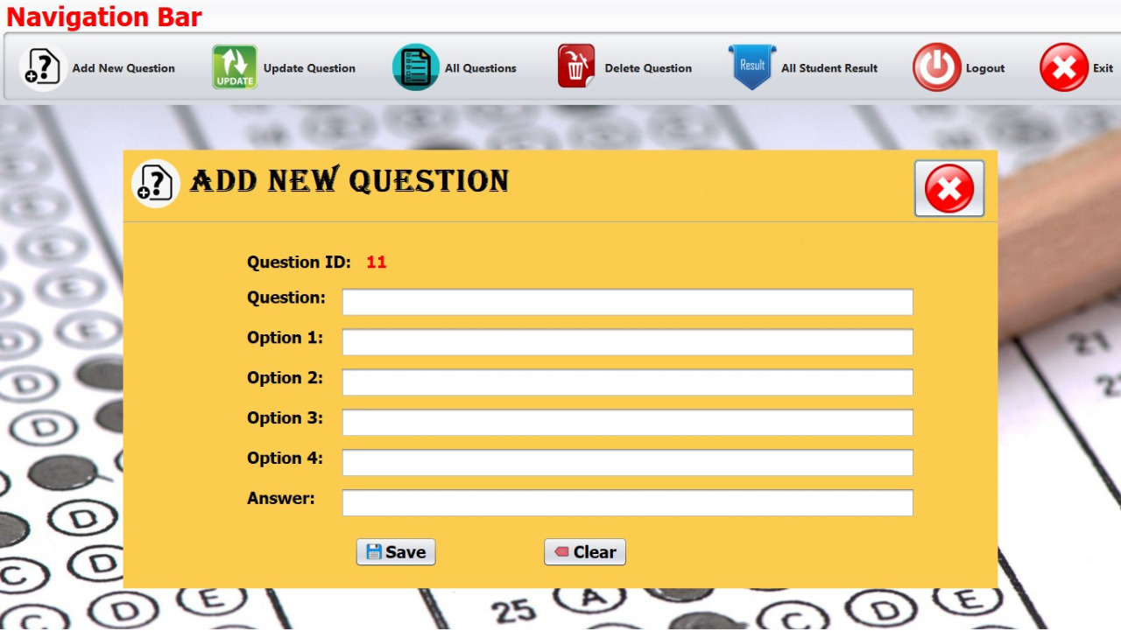

Delete Question & Update Question

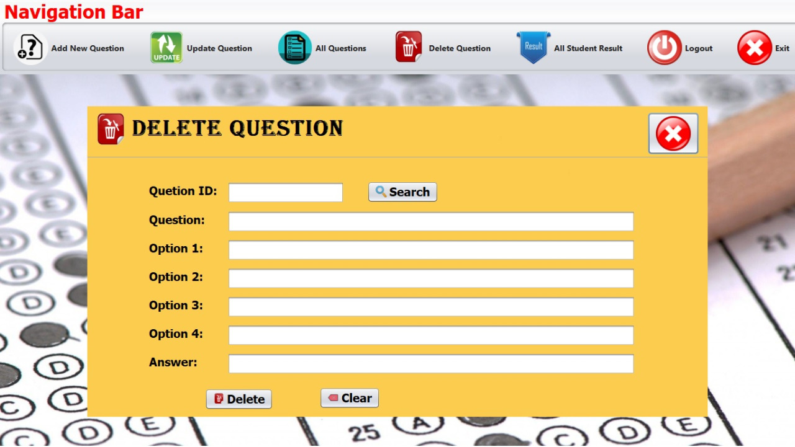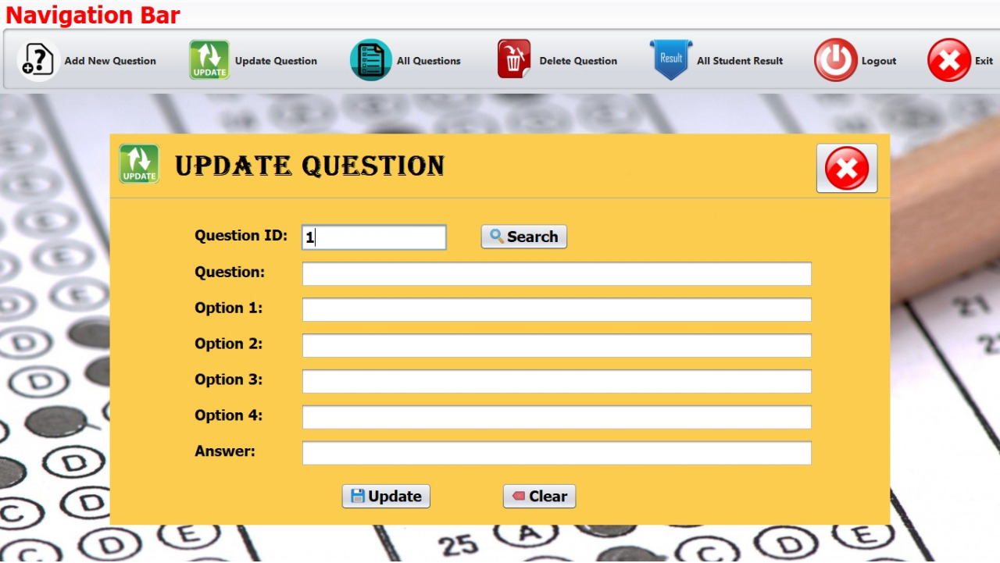

All Question in Database

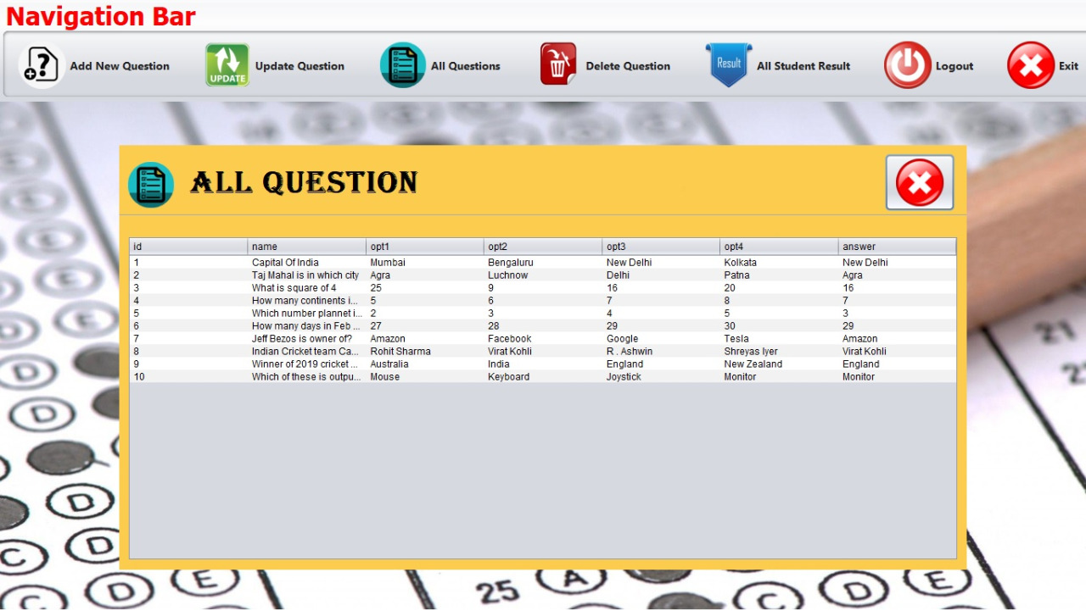

All Student Results

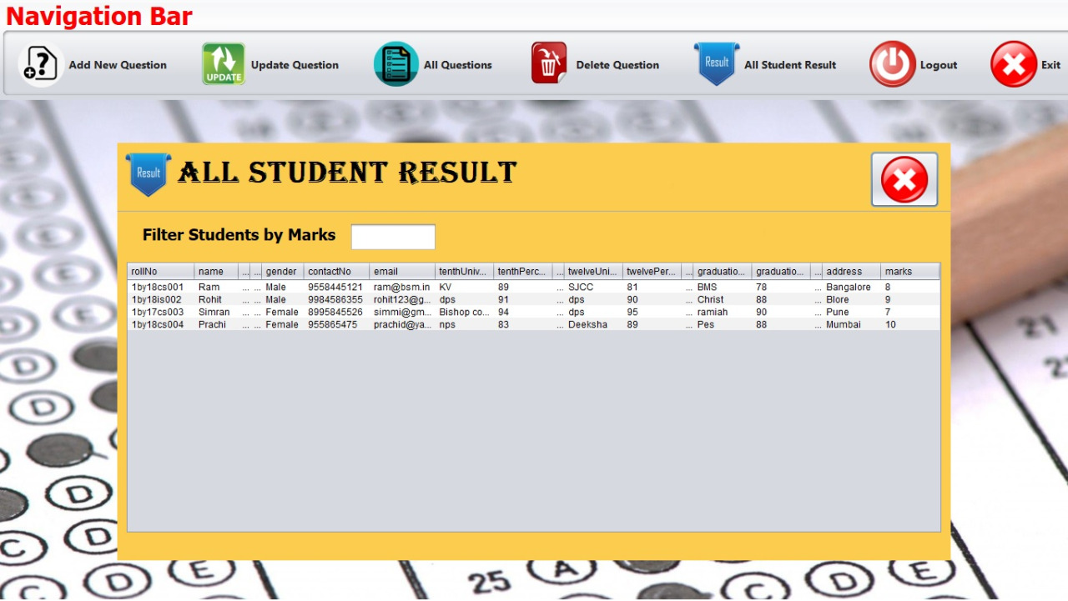

**CHAPTER 6:**

**Conclusion & Future Enhancement**

This windows application which we have developed would provide a computerized versions quiz management system which would facilitate the teachers.

It makes the entire process computerized where the teachers can add, delete, or update the quiz questions which can then be attempted by the student where they answer within a time limit, and try to score as many marks as possible. The system will also provide a log of all the attempts of his/her students who attempted the test. They can also sort the students based on marks so that its easy to manage them. This makes student marks management easier for the teachers.

The future scope of this application as in the near future is that it can be enhanced with various other features like live student tracking. Using ML algorithms to learn and analyze the mistakes made by the student and automatic provide answer keys and solutions based on there performances. It can also be enhanced by scaling up the project where multiple teachers can add their materials and multiple students can attempt various topics provided.

This current Quiz Management system application is currently developed for use in VTU subject DBMS Lab as a mini project.

**CHAPTER 7:**

**References**

* GeeksforGeeks
* Stack Overflow
* YouTube